Software Requirement Specification

for

“Autonomous Portable Dual-Axis Solar Charging Station with Shadow-Avoidance Mobility”

List of Tables

Figure No. Description Page

Figure 1.0 Monitor Live Telemetry Use Case 32
Figure 2.0 Monitor Live Telemetry Prototype 32
Figure 3.0 Analyze Historical Data Use Case 33
Figure 4.0 Analyze Historical Data Prototype 33
Figure 5.0 Manually Control Panel Orientation Use Case 34
Figure 6.0 Manually Control Panel Orientation Prototype 34
Figure 7.0 Activate Emergency Stop Use Case 35
Figure 8.0 Activate Emergency Stop Prototype 35
Figure 9.0 Configure System Parameters Use Case 36
Figure 10.0 Configure System Parameters Prototype 36
Figure 11.0 Perform Autonomous Solar Tracking Use Case 37
Figure 12.0 Perform Autonomous Solar Tracking Prototype 37
Figure 13.0 Synchronize Offline Data Use Case 38
Figure 14.0 Synchronize Offline Data Prototype 38
Figure 15.0 Review System Events Use Case 39
Figure 16.0 Review System Events Prototype 39

Introduction

In the pursuit of sustainable and renewable energy solutions, the development of intelligent and adaptive solar energy systems has become increasingly essential. The Autonomous Portable Dual-Axis Solar Charging Station with Shadow-Avoidance Mobility represents a pioneering initiative that combines embedded automation, mobility-driven shadow detection, and modern digital platforms to maximize the efficiency of solar energy harvesting. This system addresses the growing demand for portable, self-regulating energy solutions that are capable of real-time monitoring, adaptive positioning, and remote accessibility — particularly in environments where fixed solar installations are impractical or insufficient.
The Autonomous Portable Dual-Axis Solar Charging Station with Shadow-Avoidance Mobility is an integrated Internet of Things (IoT) platform engineered to optimize solar panel orientation through dual-axis motor-driven positioning while incorporating shadow-avoidance mobility to autonomously reposition the station away from obstructions that reduce energy output. At the core of the system is an ESP32/Arduino firmware layer developed in C++, responsible for sensor data acquisition, motor control logic, shadow detection, and IoT gateway communication. This embedded layer interfaces with a Laravel-based web dashboard built in PHP, which serves as the central hub for server-side API processing, real-time telemetry visualization, historical data analysis, and system event monitoring. A React Native Android application developed in JavaScript further extends the platform to mobile users, providing on-site and remote manual control, live dashboard monitoring, and system configuration management. All telemetry readings, power measurements, commands, events, and configuration data are persistently stored in a PostgreSQL database hosted through Supabase, ensuring reliable and scalable cloud-based data retention.
Embarking on this development endeavor signifies a commitment to advancing how portable solar energy systems are monitored, controlled, and optimized. By harnessing the capabilities of embedded firmware, shadow-detection algorithms, cloud infrastructure, and cross-platform software, the Autonomous Portable Dual-Axis Solar Charging Station with Shadow-Avoidance Mobility aspires to deliver a robust, intelligent, and user-friendly energy solution that empowers operators to make informed, data-backed decisions regarding solar energy utilization. This Software Requirements Specification (SRS) document serves as the authoritative reference for all functional and non-functional requirements governing the design, development, and quality assurance of the system, adhering to the IEEE 830 standard for software requirements specifications.

Purpose

This Software Requirements Specification (SRS) document describes the functional and non-functional requirements for the **Autonomous Solar Tracking Station** system. It is intended to serve as a comprehensive reference for the development team, project stakeholders, and quality assurance personnel throughout the software development lifecycle. This document follows the IEEE 830 standard for software requirements specifications.

Scope

The Autonomous Solar Tracking Station is an integrated IoT platform designed to maximize solar energy harvesting efficiency through dual-axis motor-driven panel orientation. The system encompasses:
ESP32/Arduino Firmware (C++): Sensor data acquisition, motor control logic, and IoT gateway communication.
Laravel Web Dashboard (PHP): Server-side API, real-time telemetry visualization, historical data analysis, and system event monitoring.
React Native Android Application (JavaScript):On-site and remote manual control, live dashboard monitoring, and system configuration management.
PostgreSQL Database (Supabase): Persistent cloud storage for telemetry, power readings, commands, events, and configuration data.
The software does **not** include:
- Solar panel hardware fabrication or electrical wiring design.
- Third-party weather service integrations.
- Multi-user authentication or role-based access control (single-operator system).

Definition, Acronyms, and Abbreviations

Terms | Definition
IoT | Internet of Things refers to the network of physical devices embedded with sensors, software, and connectivity that enables them to collect and exchange data over the internet.
ESP32 | A low-cost, low-power microcontroller developed by Espressif Systems with integrated Wi-Fi and Bluetooth capabilities, used in this system for sensor data acquisition, motor control, and IoT gateway communication.
Arduino | An open-source electronics platform based on easy-to-use hardware and software, used in this system as part of the embedded firmware layer for controlling hardware components.
Firmware | A specialized class of software programmed into a hardware device's non-volatile memory, providing low-level control for the device's specific hardware components.
Dual-Axis Tracking | A solar panel positioning mechanism that adjusts orientation along two axes — azimuth (horizontal) and elevation (vertical) — to follow the sun's position throughout the day and maximize energy capture.
Shadow-Avoidance Mobility | A system feature that enables the station to autonomously detect shadows or obstructions that reduce solar energy output and physically reposition itself to a more optimal location to restore maximum sun exposure.
LDR | Light Dependent Resistor is a sensor whose resistance decreases with increasing incident light intensity, used in this system to detect light levels and determine optimal solar panel orientation.
API | Application Programming Interface is a set of defined rules and protocols that allows different software applications to communicate and share data with each other.
Laravel | An open-source PHP web application framework following the Model-View-Controller (MVC) architectural pattern, used in this system to develop the server-side web dashboard and REST API.
React Native | An open-source JavaScript framework developed by Meta for building cross-platform mobile applications, used in this system to develop the Android monitoring and control application.
JavaScript | A high-level, interpreted programming language primarily used for building interactive web and mobile applications, serving as the language for the system's React Native mobile application.
PostgreSQL | An open-source, object-relational database management system known for its reliability and advanced features, used in this system as the primary database for storing telemetry, power readings, and configuration data.
Supabase | An open-source Firebase alternative that provides a cloud-hosted PostgreSQL database, authentication, and real-time subscriptions, used in this system as the cloud backend for persistent data storage.
Telemetry | The automated process of collecting and transmitting measurements and data from remote or inaccessible sources to receiving equipment for monitoring and analysis.
SRS | Software Requirements Specification is a document that describes the intended purpose, environment, and requirements — both functional and non-functional — of a software system to be developed.
IEEE | Institute of Electrical and Electronics Engineers is a professional association that develops globally recognized standards for technology and engineering, including the IEEE 830 standard followed by this document.
MVC | Model-View-Controller is a software architectural pattern that separates an application into three interconnected components to promote organized and maintainable code structure.
C++ | A general-purpose programming language with low-level memory manipulation capabilities, used in this system for writing the embedded firmware that runs on the ESP32/Arduino microcontroller.
Prototype | An early working model of the system created to demonstrate and validate the basic features, functionality, and design of the product before full-scale development and deployment.
Table1.0 Definitions, Acronyms, and Abbreviations

References
- Aliyu, A. M., et al. (2021). Dual-axis solar tracking system using microcontroller and light dependent resistors. International Journal of Renewable Energy Research, 11(2), 45–53.
- Espressif Systems. (2023). ESP32 Technical Reference Manual. Espressif Systems. Retrieved from https://www.espressif.com/en/support/documents/technical-documents
- Ottosson, J., & Larsson, M. (2020). IoT-based real-time monitoring systems for renewable energy applications. IEEE Transactions on Industrial Electronics, 67(4), 2890–2899.
- Laravel. (2023). Laravel — The PHP Framework for Web Artisans. Laravel LLC. Retrieved from https://laravel.com/docs
- Meta Platforms, Inc. (2023). React Native — Learn once, write anywhere. Meta Open Source. Retrieved from https://reactnative.dev/docs/getting-started
- Supabase Inc. (2023). Supabase Documentation — The Open Source Firebase Alternative. Retrieved from https://supabase.com/docs
- PostgreSQL Global Development Group. (2023). PostgreSQL 15 Documentation. Retrieved from https://www.postgresql.org/docs/
- Choi, Y., et al. (2020). Shadow detection and avoidance in mobile solar energy harvesting systems. Renewable Energy, 152, 768–779.
- IEEE. (1998). IEEE Std 830-1998 — IEEE Recommended Practice for Software Requirements Specifications. Institute of Electrical and Electronics Engineers.
- Seme, S., et al. (2020). Solar photovoltaic tracking systems for electricity generation: A review. Energies, 13(16), 4224. https://doi.org/10.3390/en13164224

Overall Description

The Autonomous Portable Dual-Axis Solar Charging Station with Shadow-Avoidance Mobility is designed to be a comprehensive embedded IoT platform that autonomously maximizes solar energy harvesting efficiency through intelligent panel orientation and mobile shadow-avoidance capabilities. The system aims to enhance the reliability, portability, and performance of solar energy collection by integrating real-time sensor feedback, dual-axis motor control, and cloud-based monitoring accessible through both web and mobile platforms.
In this section, the overall description of the Autonomous Portable Dual-Axis Solar Charging Station with Shadow-Avoidance Mobility shall be outlined, covering the system's essential features, functionality, constraints, assumptions, and dependencies. All data gathered as part of this Software Requirements Specification shall serve as the basis for the concept, design, and development of the system.

Product Perspective

Autonomous solar tracking and portable solar energy systems represent a growing area of innovation in the field of renewable energy technology. As the demand for efficient and adaptive energy solutions continues to rise, the integration of embedded automation, shadow-detection algorithms, and real-time cloud-based monitoring has become increasingly significant in maximizing the output of solar installations. These systems provide a structured and intelligent approach to solar energy harvesting, enabling continuous optimization of panel positioning in response to changing environmental conditions.
Autonomous solar charging systems play a crucial role in ensuring the efficiency, adaptability, and sustainability of portable energy solutions. They serve as a valuable technological asset for applications where consistent and optimized solar energy harvesting is critical, particularly in off-grid, remote, or dynamically shaded environments. By combining hardware automation with digital monitoring platforms, such systems are capable of delivering measurable improvements in energy output while reducing the need for manual intervention.
The system will employ a range of modern and proven technologies across its hardware and software layers. At the embedded level, the system will utilize ESP32/Arduino microcontrollers programmed in C++ for sensor data acquisition, dual-axis motor control, shadow detection, and IoT gateway communication. For the server-side web dashboard, the system will use Laravel as the backend framework built on PHP, following the Model-View-Controller (MVC) architectural pattern to ensure a clean and maintainable codebase. The front-end of the web dashboard will be developed using HTML, CSS, Bootstrap, and JavaScript to deliver a responsive and user-friendly interface. The mobile application will be developed using React Native in JavaScript to provide cross-platform Android accessibility. PostgreSQL, hosted through Supabase, will serve as the cloud database server for persistent storage of telemetry, power readings, events, commands, and configuration data.

Product Functions

The system provides the following high-level functions:
Autonomous Solar Tracking — Automatically orient solar panels toward the highest light intensity using a 6-sensor LDR array and dual-axis servo motors.
Real-Time Telemetry Monitoring — Display live sensor readings (light, voltage, angles, distance) on both web and mobile interfaces.
Historical Data Analysis — Visualize trends in light intensity, power generation, and servo positions over configurable time ranges.
Manual Override Control — Allow the operator to manually adjust panel orientation via mobile app (Bluetooth/API) with directional pad and precision controls.
Obstacle Detection & Avoidance — Use ultrasonic sensor scanning to detect physical obstructions and execute evasion sequences.
Emergency Stop — Provide a software-triggered emergency halt of all motor activity for safety.
Remote Configuration — Enable adjustment of tracking thresholds, servo home positions, motor speed, and polling intervals from the mobile application.
Offline Data Buffering— Queue telemetry data locally on the ESP32 (SPIFFS) when the network is unavailable and synchronize upon reconnection.
System Event Logging — Record and categorize system events (errors, warnings, mode changes) for auditing and troubleshooting.
Upload Status Monitoring — Track the health and progress of data synchronization between the station and the cloud.

User Characteristics

The system is designed for a single operator who assumes the role of both administrator and end-user:
Characteristic:
Technical Proficiency : Moderate to advanced; familiar with IoT hardware and web/mobile interfaces
Usage Context : On-site monitoring via mobile app; remote analysis via web
Primary Goal :Maximize solar energy collection and monitor station healt
Interaction Frequency :Periodic monitoring with occasional manual intervention.
Administrator Full access to all system features including Dashboard, Dual-Axis Tracking Control, Shadow-Avoidance Mobility Settings, Real-Time Telemetry Monitoring, Remote Manual Control, Historical Data Analysis, System Event Monitoring, System Configuration Management, and Reports.
Field Operator Access to Dashboard, Real-Time Telemetry Monitoring, Remote Manual Control, and System Event Monitoring. Responsible for on-site supervision and manual override of system operations when necessary.
Analyst / Viewer Read-only access to Dashboard, Historical Data Analysis, and Reports. Responsible for evaluating system performance and generating energy efficiency documentation without the ability to modify system settings or controls.

Constraints

Hard Constraints

Hard constraints are absolutely non-negotiable and must be satisfied by any feasible solution to the system.

Hardware Compatibility The system firmware must operate exclusively on ESP32/Arduino-compatible microcontrollers. Any deviation from the supported hardware platform renders the embedded control layer non-functional.
Internet Connectivity Real-time telemetry transmission, cloud data storage, and remote control features require a stable internet connection. The absence of connectivity will prevent live monitoring and remote operation of the system

Power Supply The embedded control system and mobility mechanisms require a minimum power threshold to operate. Insufficient power input will halt motor control, shadow-avoidance, and communication functions entirely
Database Availability The PostgreSQL database hosted through Supabase must remain accessible for all data logging, reporting, and historical analysis features. Prolonged database unavailability will result in loss of telemetry records and system event logs.

Soft Contraints

Soft constraints, on the other hand, are conditions that may be negotiated or adjusted based on circumstances without fundamentally compromising the system's feasibility.
Tracking Sensitivity Preferred thresholds for LDR sensitivity and motor response timing may be adjusted based on deployment environment and operator preferences without affecting core system functionality.
Mobility Range The operational movement boundary for shadow-avoidance repositioning may be configured and modified based on the physical deployment area and the operator's preferred mobility limits.
Reporting Frequency The desired frequency of automated report generation and telemetry data logging intervals may be adjusted by the administrator to balance system performance with storage and bandwidth considerations.

2.5 Assumptions and Dependencies

An assumption is a statement that is generally considered to be true without proof or evidence, while a dependency means that one task or activity is reliant on another. The following are the assumptions and dependencies established in order to maximize the utilization of the Autonomous Portable Dual-Axis Solar Charging Station with Shadow-Avoidance Mobility:
Hardware Availability and Compatibility It is assumed that all required hardware components — including the ESP32 microcontroller, LDR sensors, servo or stepper motors, and mobility chassis — are available, functional, and compatible with the system's firmware and control logic throughout the development and deployment lifecycle.
Stable Internet Connectivity It is assumed that the deployment environment will have a stable and reliable internet connection to support real-time telemetry transmission to the Supabase cloud database and to enable remote monitoring and control through the web dashboard and mobile application.
User Technical Proficiency The system assumes that operators and administrators possess a basic level of technical proficiency sufficient to navigate the web dashboard and mobile application, interpret telemetry data, and perform manual control and configuration tasks effectively.
Software Dependencies The web dashboard and API server depend on Laravel, PHP, and their associated libraries being properly installed and configured on the server environment. The mobile application depends on the React Native runtime and its required packages being present on the development and build system.

Security Measures It is assumed that basic security measures — such as secured Wi-Fi networks, API authentication, and access control — will be in place to complement the system's built-in data protection mechanisms and prevent unauthorized access to the platform and its data.
Backup and Recovery Solutions The integrity and availability of stored telemetry, power readings, and configuration data depend on the cloud backup and recovery mechanisms provided by Supabase, as well as any additional backup procedures that administrators must implement to safeguard against data loss or corruption.
Environmental Suitability It is assumed that the station will be deployed in an outdoor environment with sufficient exposure to sunlight and adequate surface area to allow shadow-avoidance mobility without significant physical obstructions that would prevent repositioning.

Specific Requirements

This section of the SRS identifies the system's hardware and software interfaces, the user interface's fundamental prototypes, and the functional and performance requirements, design constraints, and software system attributes of the Autonomous Portable Dual-Axis Solar Charging Station with Shadow-Avoidance Mobility.

External Interfaces Requirements

3.1.1. External Interface Requirements
External Interface Requirements specify the hardware and software with which the system must interface. This section provides information to ensure that the system will communicate properly with all external components involved in its operation.
3.1.2. Hardware Interfaces
The system relies on a set of embedded and peripheral hardware components to carry out its tracking, shadow-avoidance, and communication functions. Below are the minimum hardware specifications required for the system to operate:
Server:
• Microcontroller: ESP32 (240 MHz dual-core processor, integrated Wi-Fi and Bluetooth)
• Light Sensors :4x Light Dependent Resistors (LDR) for dual-axis solar tracking and shadow detection
• Motor Actuators: Servo or stepper motors for horizontal (azimuth) and vertical (elevation) panel orientation control
• Mobility Drive System: DC motors with motor driver module (e.g., L298N) for autonomous station repositioning
• Solar Panel: Photovoltaic solar panel (minimum 10W) mounted on the dual- axis tracking frame
• Web Server (Dashboard): Processor: 3.00 GHz | RAM: 8 GB DDR4 | Storage: 500 GB SSD
• Client Device (Mobile) :Android smartphone running Android 10 or higher with Wi-Fi or mobile data connectivity

3.1.3. Software Interfaces
Server:
• Operating System (Server) :Windows 11 / Ubuntu 22.04 LTS
• Embedded Firmware Language: C++ via Arduino IDE / PlatformIO
• Backend Framework: Laravel (PHP) — REST API and web dashboard server
• Frontend Design: HTML, CSS, Bootstrap, JavaScript
• Mobile Application: React Native (JavaScript) — Android
• Database :PostgreSQL via Supabase (cloud-hosted)
• Web Server: Apache 2.4.x
• Communication Protocol :MQTT / HTTP REST API over Wi-Fi (ESP32 to server)
• Diagram Tool: Draw.io (system architecture and use case diagrams)

Functional Requirements

3.2.1 Use Case
3.2.1.1 Monitor Live Telemetry
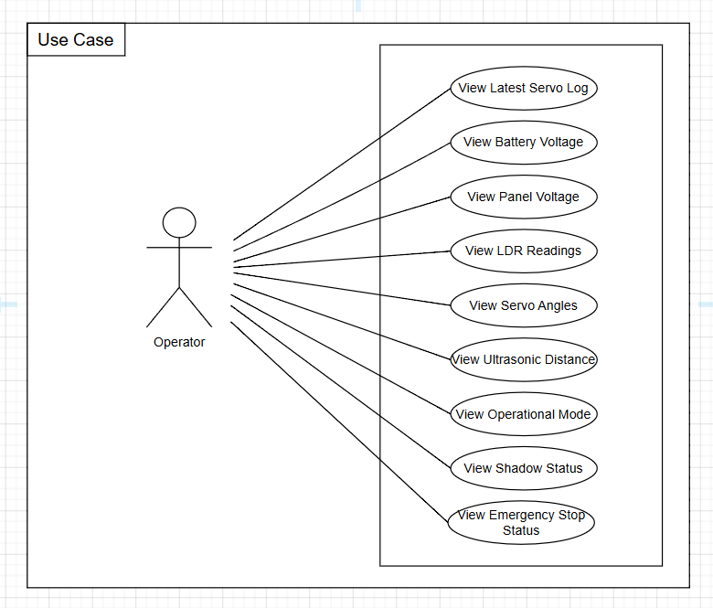

Figure 1.0 Monitor Live Telemetry Use Case
3.2.2.1 Monitor Live Telemetry Prototype
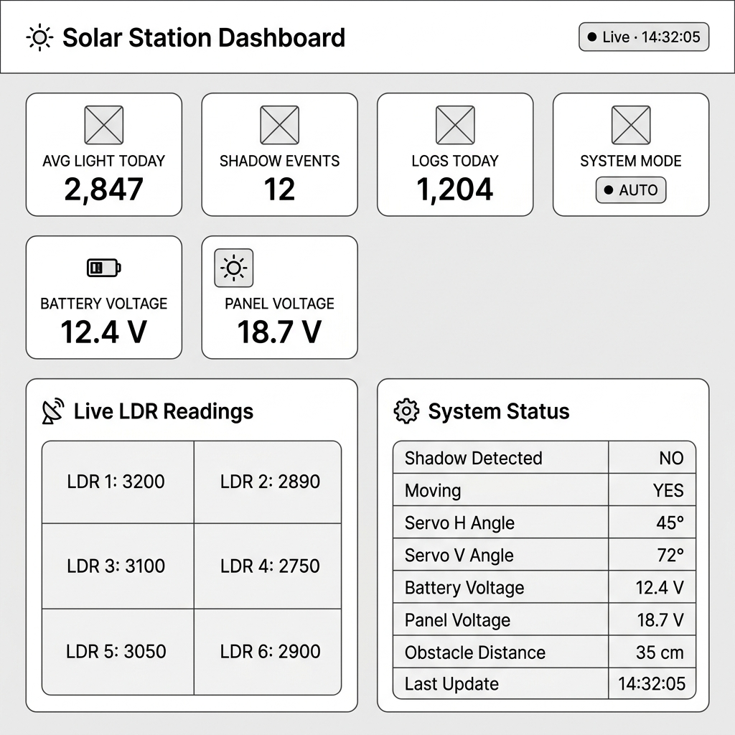
Figure 2.0 — Monitor Live Telemetry Prototype

3.2.1.2 Analyze Historical Data Use Case

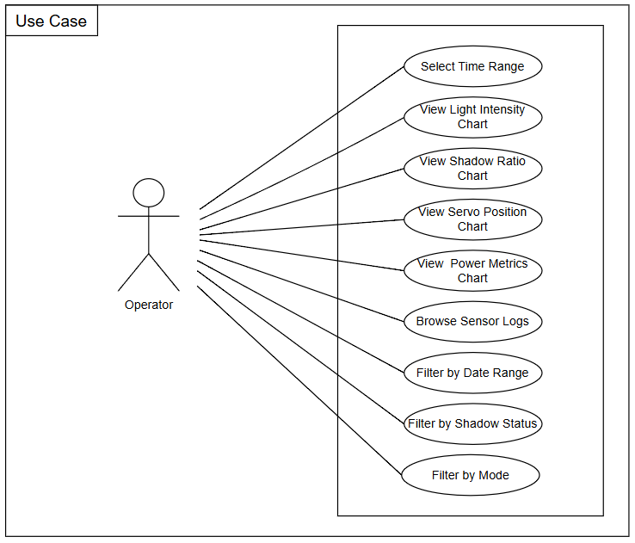
Figure 3.0 Analyze Historical Data Use Case
3.2.2.2. Analyze Historical Data Prototype
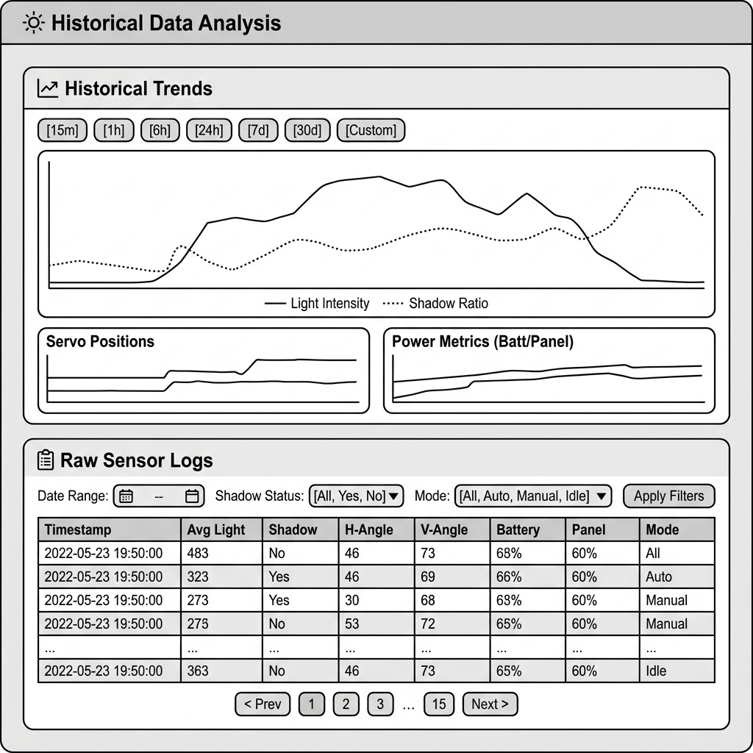
Figure 4.0 Analyze Historical Data Prototype

3.2.1.3 Manually Control Panel Orientation
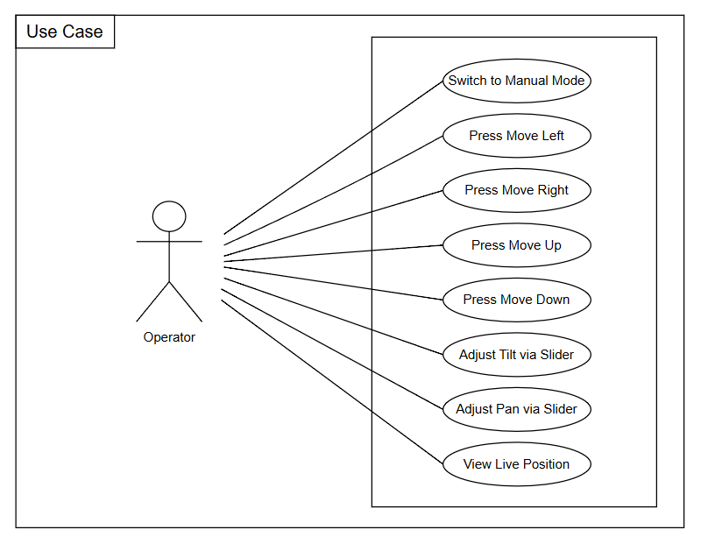
Figure 5.0 Manually Control Panel Orientation Use Case

3.2.2.3. Manually Control Panel Orientation Prototype

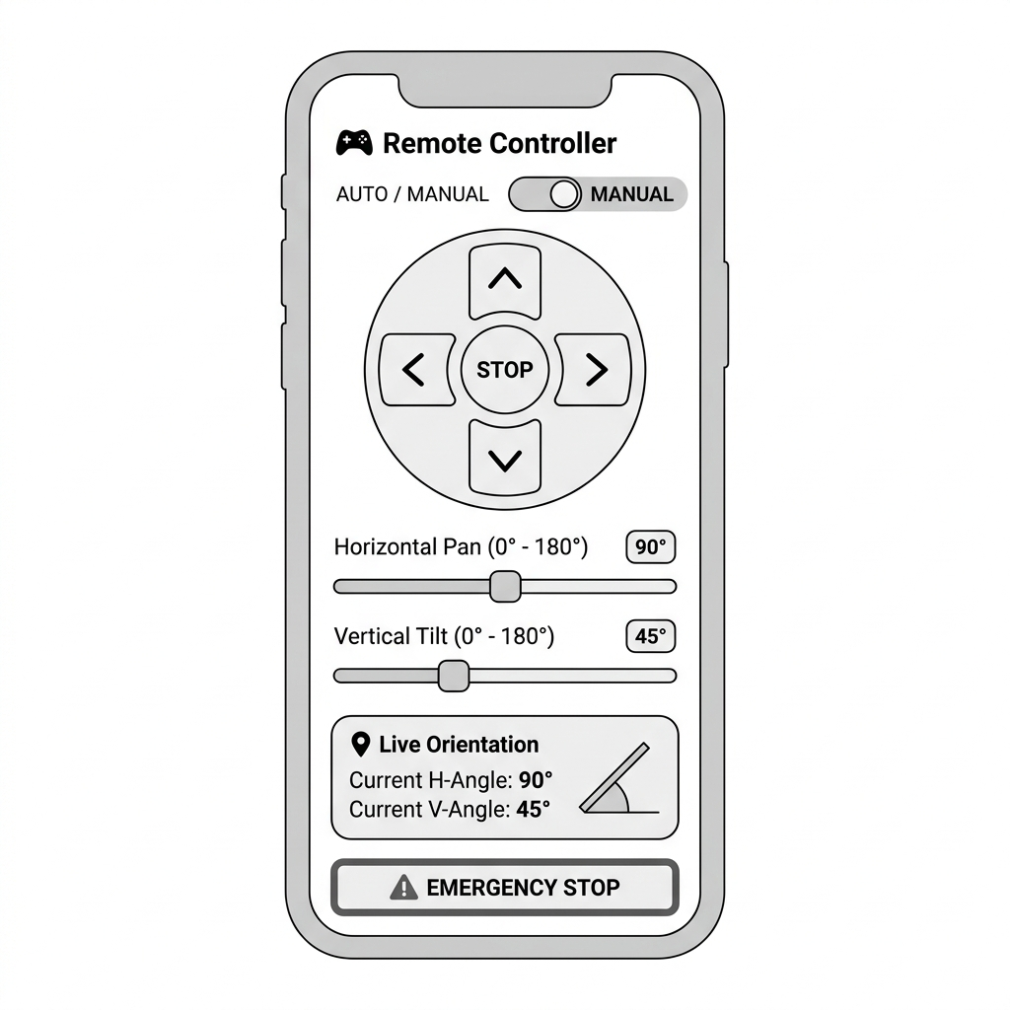
Figure 6.0 Manually Control Panel Orientation Prototype

3.2.1.4. Activate Emergency Stop Use Case
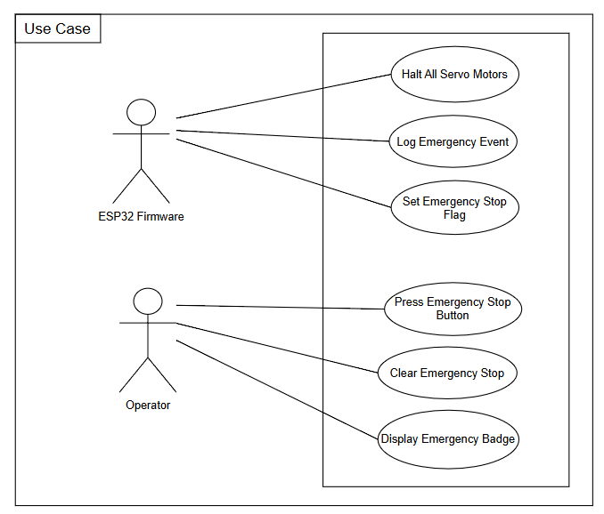
Figure 7.0 Activate Emergency Stop Use Case

3.2.2.4. Activate Emergency Stop Prototype
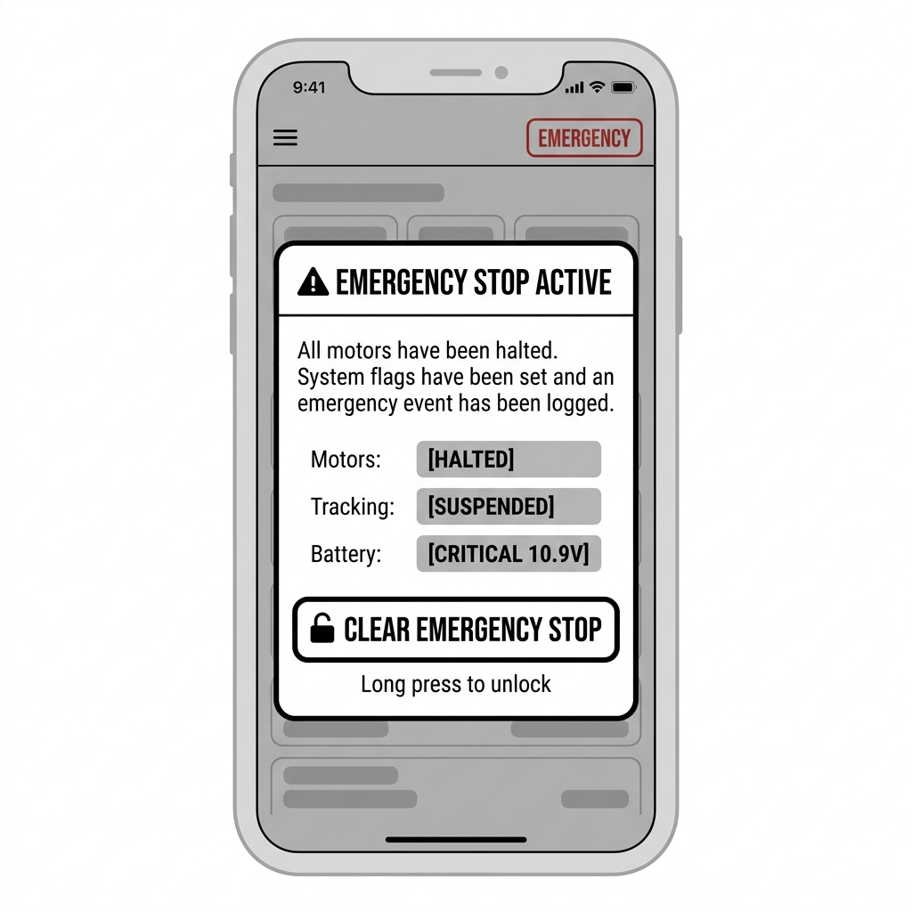
Figure 8.0 Activate Emergency Stop Prototype
3.2.1.5. Configure System Parameters Use Case

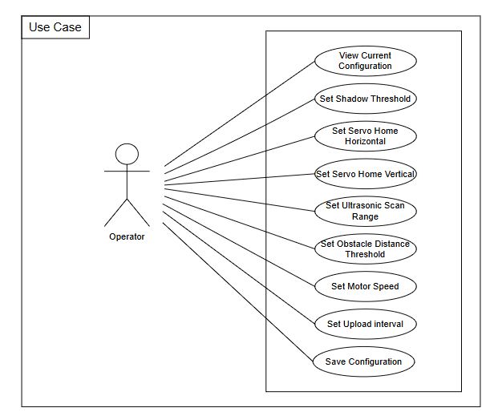
Figure 9.0 Configure System Parameters
3.2.2.5. Configure System Parameter Prototype
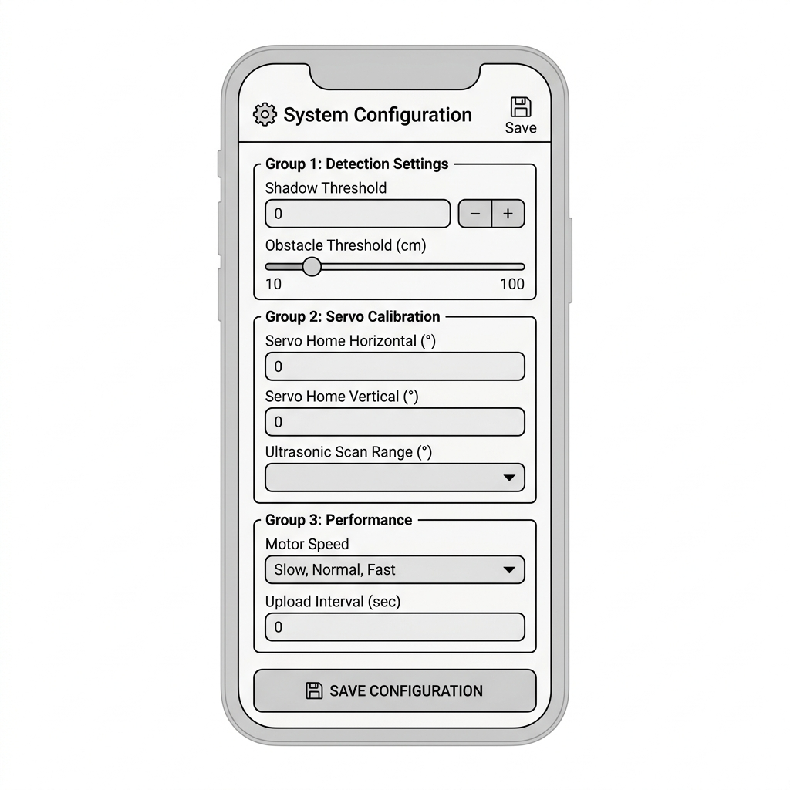
Figure 10.0 Configure System Parameter Prototype

3.2.1.6. Perform Autonomous Solar Tracking Use Case

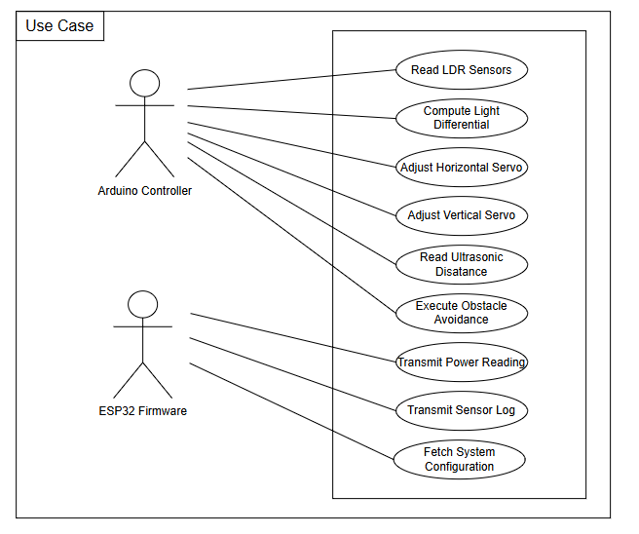
Figure 11.0 Perform Autonomous Solar Tracking Use Case
3.2.2.6. Perform Autonomous Solar Tracking Prototype

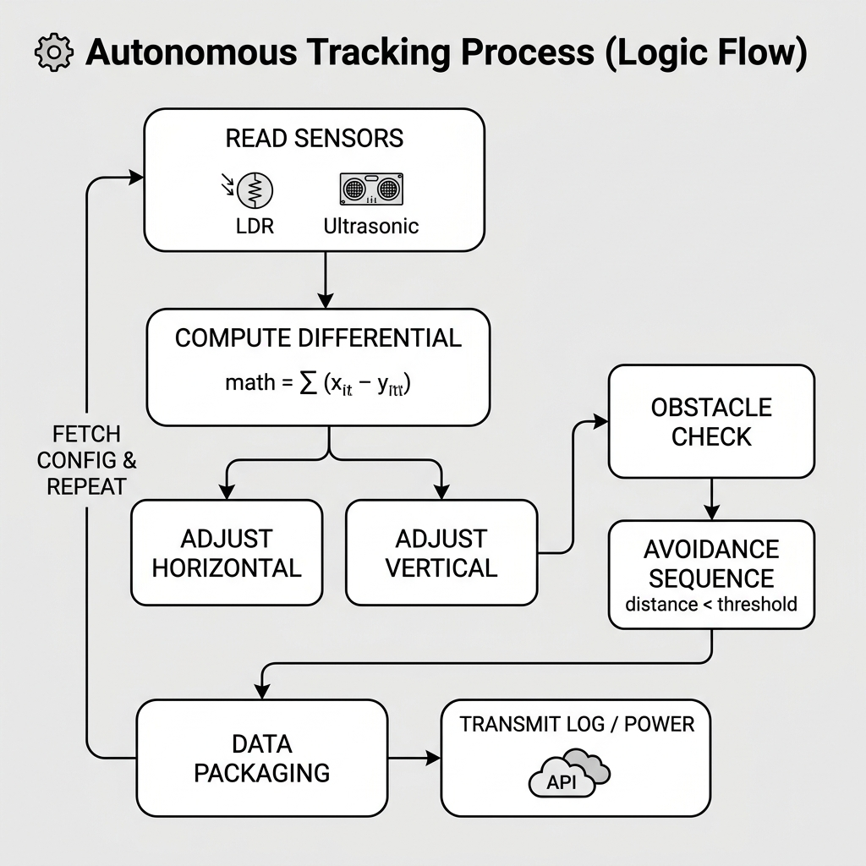

Figure 12.0 Perform Autonomous Solar Tracking Prototype
3.2.1.7. Synchronize Offline Data Use Case
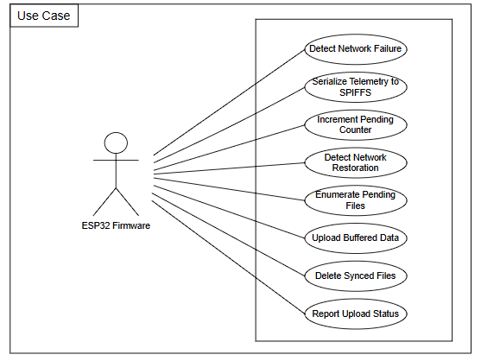
Figure 13.0 Synchronize Offline Data Use Case

3.2.2.7. Synchronize Offline Data Prototype

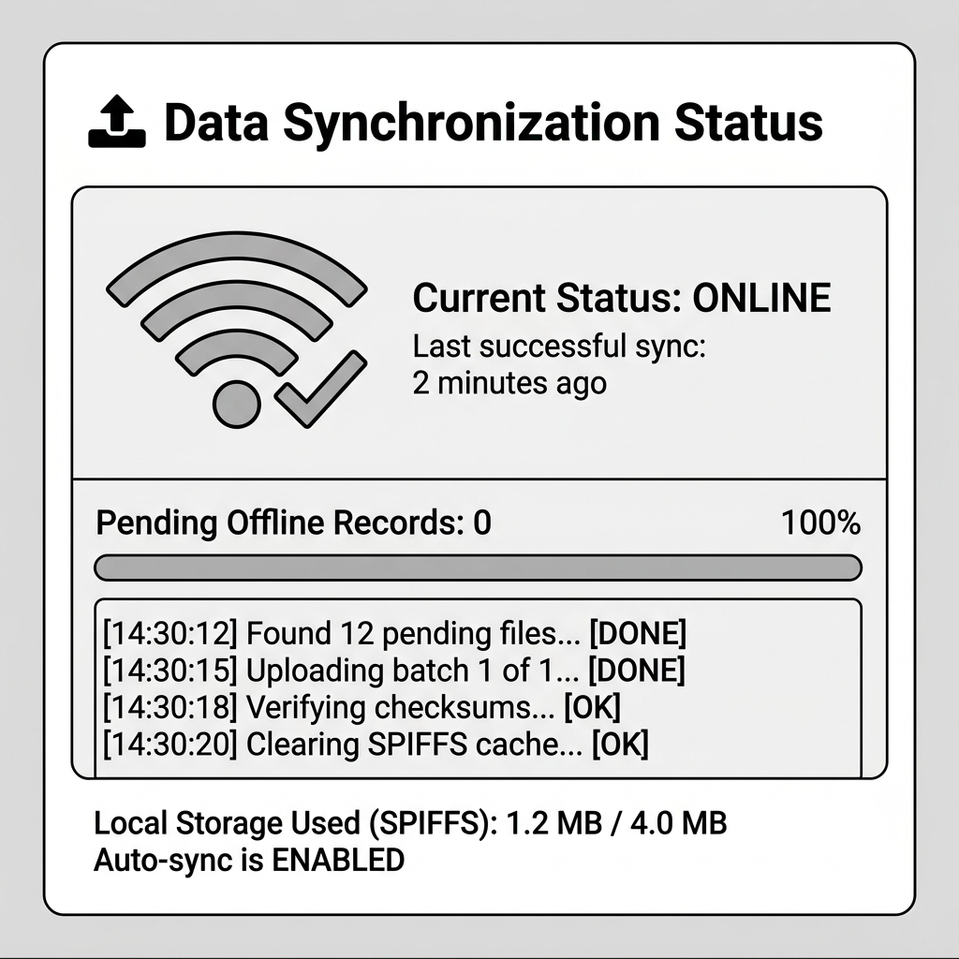

Figure 14.0 Synchronize Offline Data Prototype
3.2.1.8. Review System Events Use Case
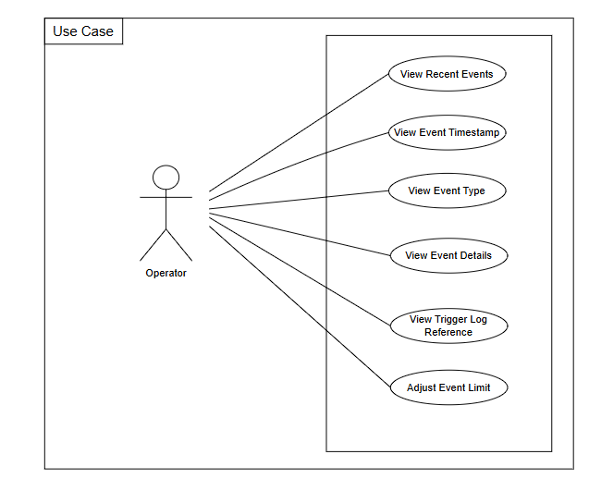
Figure 15.0 Review System Events Use Case

3.2.2.8. Review System Events Prototype

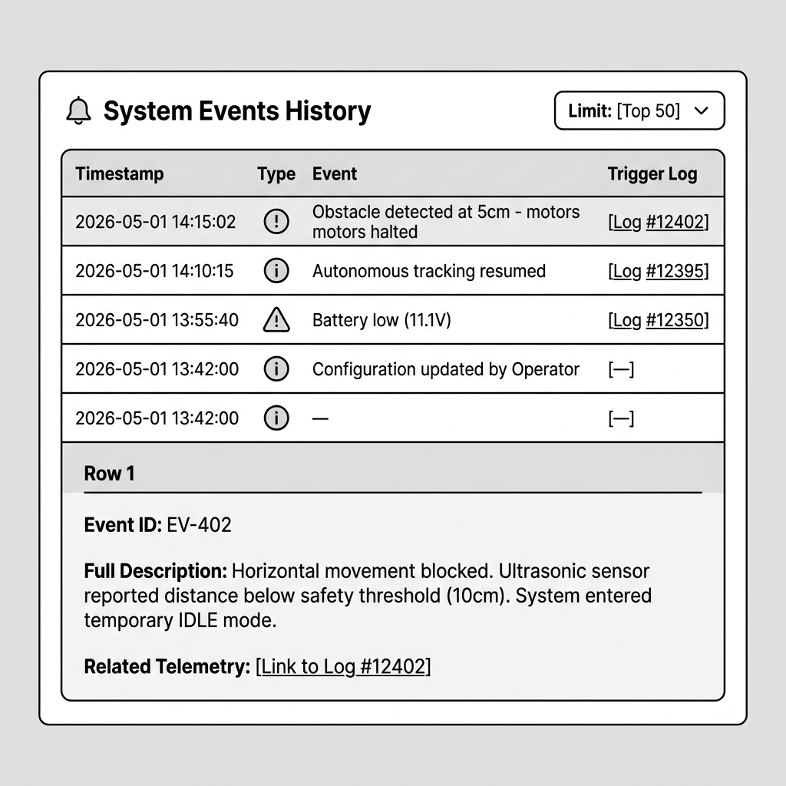
Figure 16.0 Review System Events Prototype

Performancce Requirements

Performance requirements define how well the system performs certain functions to meet its intended goals. They help ensure that the Autonomous Portable Dual-Axis Solar Charging Station with Shadow-Avoidance Mobility functions efficiently and effectively, meeting operator expectations and energy optimization objectives.Performance requirements define how well the system performs certain functions to meet its intended goals. They help ensure that the Autonomous Portable Dual-Axis Solar Charging Station with Shadow-Avoidance Mobility functions efficiently and effectively, meeting operator expectations and energy optimization objectives.

3.3.1 Execution Time

In general, the execution time of the system refers to the amount of time it takes for a specific process or operation to complete. For the Autonomous Portable Dual-Axis Solar Charging Station with Shadow-Avoidance Mobility, execution time is a critical performance factor across multiple layers of the system. The response time of the ESP32 firmware for sensor reading and motor actuation must be sufficiently fast to enable real-time tracking adjustments, typically within milliseconds of detecting a change in light intensity. Telemetry data transmission from the embedded layer to the Supabase cloud database must be completed within an acceptable latency window to ensure that the web dashboard and mobile application reflect near-real-time system status. Similarly, shadow-avoidance mobility decisions — from shadow detection to motor activation — must be executed promptly to minimize energy loss due to prolonged obstruction. Execution time may be influenced by factors including microcontroller processing speed, Wi-Fi signal strength, network latency, database query complexity, and the volume of concurrent data being processed.

3.3.2. Efficiency

The system is designed to maximize solar energy harvesting efficiency through continuous dual-axis tracking and autonomous shadow-avoidance repositioning. By intelligently orienting the solar panel to follow the sun's trajectory and proactively avoiding shaded positions, the system significantly improves power output compared to fixed-panel installations. On the software side, efficiency is achieved through optimized firmware logic that minimizes unnecessary motor activations, streamlined API communication between the ESP32 and the cloud backend, and responsive dashboard interfaces that deliver telemetry insights with minimal overhead. Achieving sustained high efficiency requires careful calibration of sensor thresholds, continuous monitoring of system performance metrics, and periodic review of energy generation data to identify and address inefficiencies in panel positioning or mobility behavior.

Design Constraints

This section specifies the design constraints imposed on the Autonomous Portable Dual-Axis Solar Charging Station with Shadow-Avoidance Mobility by hardware limitations, software standards, and technology choices made during the system's development.
    - Software Language

The system is developed using a combination of programming languages suited to each of its components. The embedded firmware is written in C++ using the Arduino IDE and PlatformIO framework, which imposes constraints tied to the memory and processing limitations of the ESP32 microcontroller. The web dashboard backend is developed in PHP using the Laravel framework, requiring a compatible PHP version and server environment. The mobile application is written in JavaScript using the React Native framework, constraining the application to platforms and environments supported by the React Native runtime. All software components must adhere to their respective language standards and framework conventions to ensure interoperability, maintainability, and long-term stability of the system.
    - Graphical User Interface

The graphical user interface of the web dashboard is built using a combination of HTML, CSS, Bootstrap, and JavaScript, which constrains the visual design and interactivity of the platform to technologies supported by standard web browsers. The mobile application interface is constructed using React Native's component-based UI framework, which defines the layout, navigation patterns, and interaction behavior available to mobile users. Both interfaces are designed to be responsive and intuitive, prioritizing clarity in the display of real-time telemetry data, panel orientation status, and system event logs. The use of Bootstrap for the web dashboard ensures consistent cross-browser compatibility, while React Native ensures a native-like user experience on Android devices.

Software System Attribute

For the Autonomous Portable Dual-Axis Solar Charging Station with Shadow-Avoidance Mobility — a system designed to automate and optimize solar energy harvesting through intelligent tracking and mobility — several software system attributes are considered crucial to its success and sustainability.

    - Reliability

The Autonomous Portable Dual-Axis Solar Charging Station with Shadow-Avoidance Mobility is built to be reliable. The embedded firmware is designed to operate continuously without failure, ensuring that dual-axis tracking adjustments and shadow-avoidance mobility decisions are executed consistently and accurately throughout the system's operational lifetime. The cloud database and web dashboard are structured to minimize downtime and ensure that telemetry data recorded and displayed accurately reflects the actual performance and status of the solar station. Reliability in data integrity is maintained through validated sensor readings and structured data storage protocols in the PostgreSQL database hosted via Supabase.

    - Availability

The Autonomous Portable Dual-Axis Solar Charging Station with Shadow-Avoidance Mobility is designed to be continuously available. The embedded firmware operates autonomously without requiring manual intervention, allowing the system to perform solar tracking and shadow avoidance at all times during daylight hours. The web dashboard and mobile application are available to authorized users at any time through internet connectivity, ensuring that operators can monitor system status, review historical data, and issue manual control commands without being physically present at the deployment site. Cloud infrastructure through Supabase further ensures that data storage and retrieval remain accessible regardless of the operator's location.

    - Security

The Autonomous Portable Dual-Axis Solar Charging Station with Shadow-Avoidance Mobility incorporates security measures across all of its software layers to protect system integrity and prevent unauthorized access. Communication between the ESP32 firmware and the cloud backend is secured through authenticated API endpoints and encrypted data transmission protocols. Access to the web dashboard and mobile application is restricted to authorized operators through credential-based authentication. The Supabase cloud database applies row-level security policies to ensure that stored telemetry and configuration data are accessible only to verified users. These measures collectively safeguard the system against unauthorized control commands, data tampering, and breaches of operational integrity.

    - Maintainability

The Autonomous Portable Dual-Axis Solar Charging Station with Shadow-Avoidance Mobility is designed with maintainability as a core software attribute. The web dashboard backend follows the Model-View-Controller (MVC) architectural pattern through Laravel, promoting a clean separation of concerns that simplifies future modifications, debugging, and feature additions. The embedded firmware is structured in modular functions to allow individual components — such as the tracking algorithm, shadow detection logic, and mobility control — to be updated or replaced independently. System performance, health, and connectivity are monitored through the dashboard's event logging features, enabling administrators to identify and resolve issues proactively. Regular software updates, firmware patches, and dependency upgrades must be applied to maintain system integrity and address emerging vulnerabilities.

    - Portability

The Autonomous Portable Dual-Axis Solar Charging Station with Shadow-Avoidance Mobility is inherently portable both physically and in terms of software deployment. The station's compact and mobile chassis allows it to be relocated to different outdoor environments as needed, with the embedded system resuming full operation upon reconnection to a power source and Wi-Fi network. On the software side, the Laravel web dashboard can be deployed on any server environment that supports PHP and Apache, while the React Native mobile application can be compiled and distributed for Android devices across varying hardware specifications. The use of Supabase as a cloud-hosted database eliminates dependency on any specific local server infrastructure, further enhancing the system's portability and ease of deployment across diverse operational settings.

